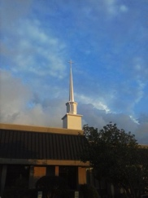
April 2018
Anglican Church of the Holy Trinity
Christ-centered, biblically grounded, worshipping in the Anglican Tradition

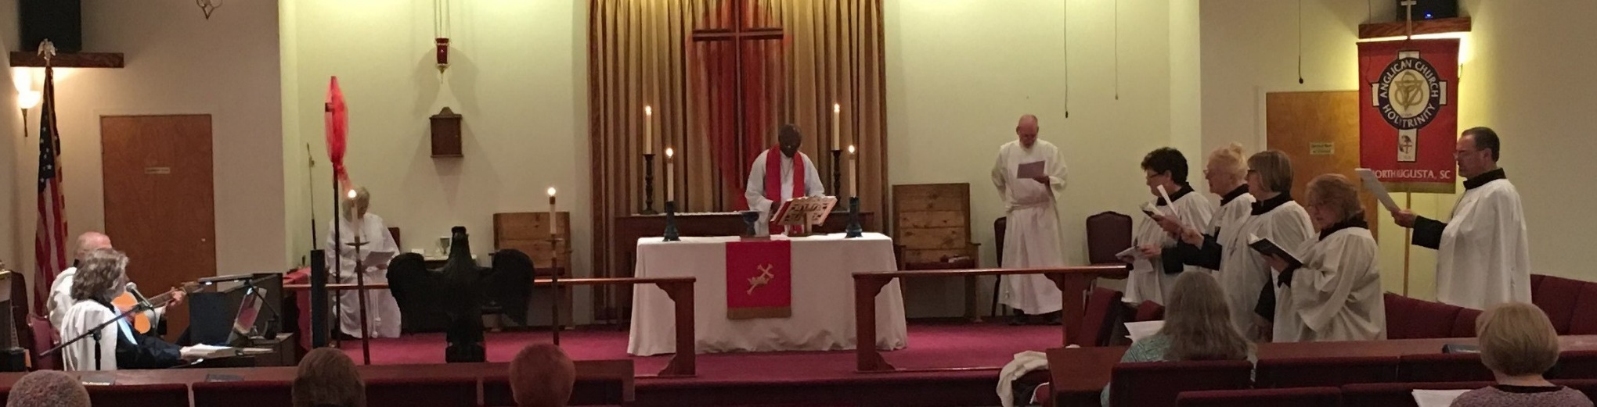
Holy Week and Easter - 2018
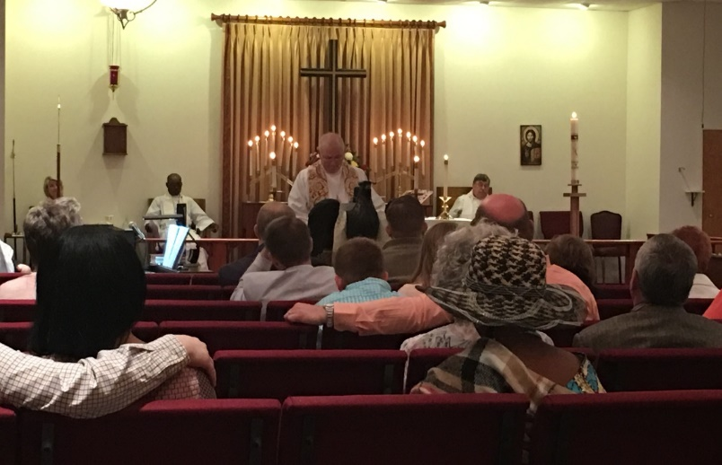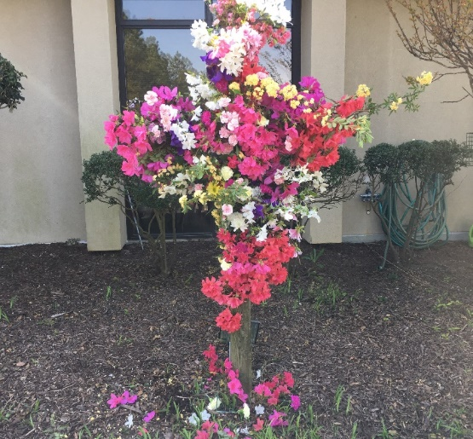

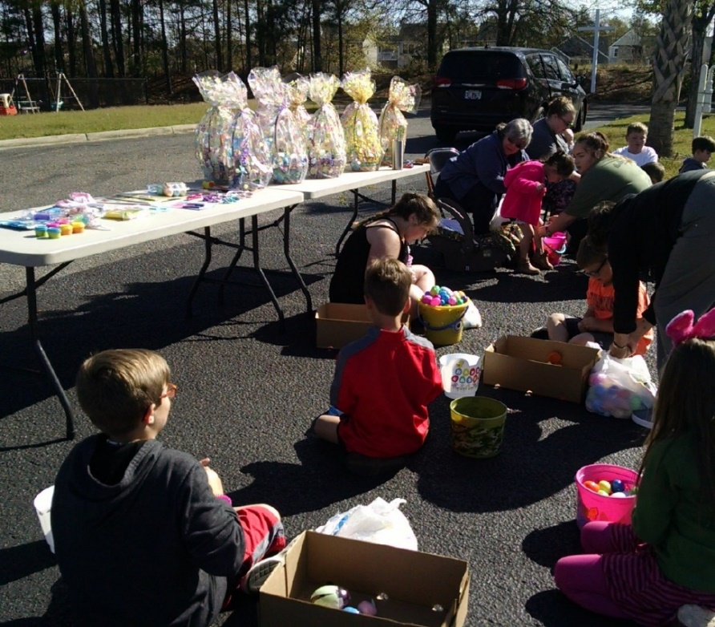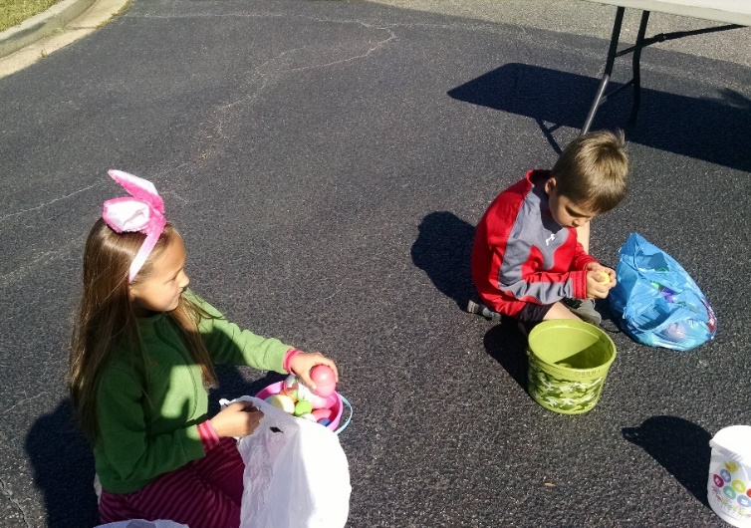

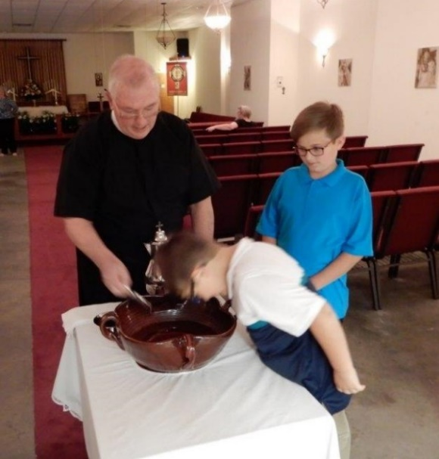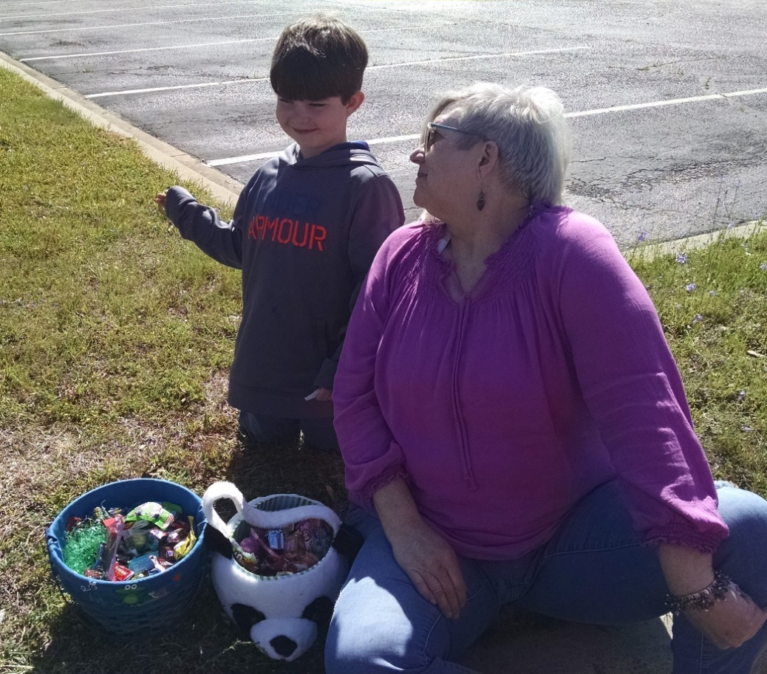

Newsletter

Easter-2018

Holy Trinity
A beacon drawing people to God and
into the fellowship
of God’s people.

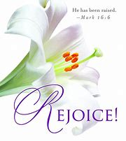

HT Mobile Phone App
Check it out!
Go to achtna.org
Click on “Download Our Mobile App.”

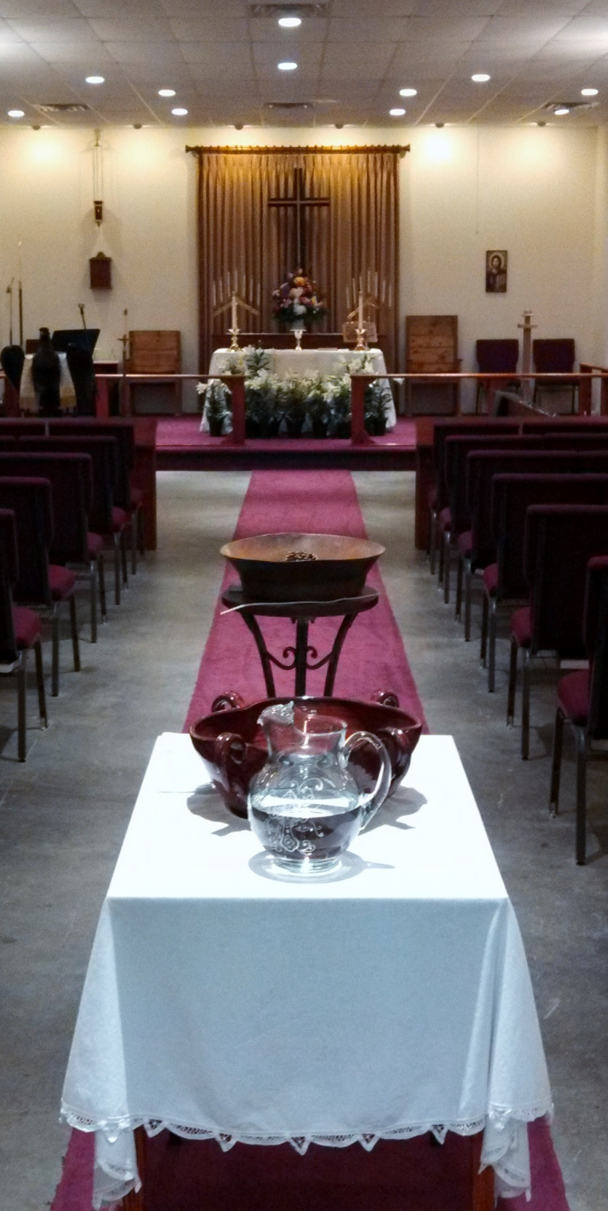

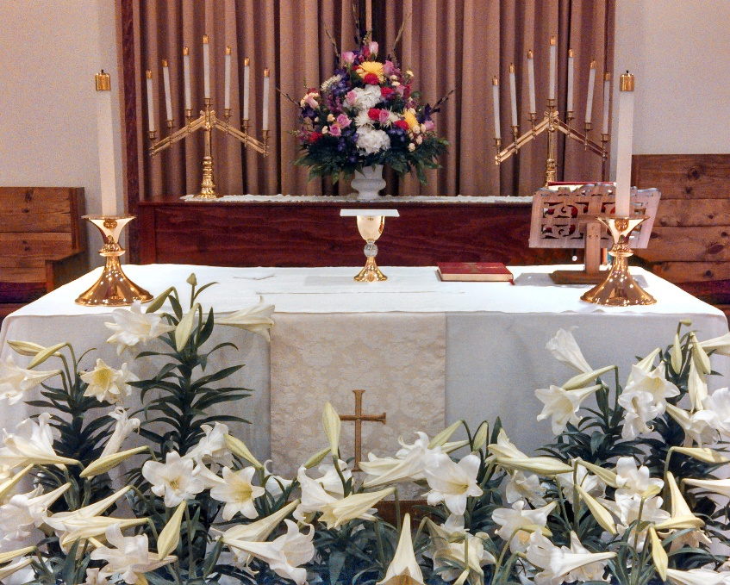

Sacred Space
Moses was in the desert tending his father-in-law’s sheep when he encountered a burning bush that was not consumed by the flames (Exodus 3:1-15). He “turned aside” to see this marvelous thing. God instructed Moses to take off his shoes because this is “Holy Ground,” holy because God was uniquely present. In that place, Moses communed with God. His life was never to be the same.

Our worship space at Holy Trinity is, for us, “Holy Ground.” It is here that we, like Moses, “turn aside” from our daily lives and uniquely encounter God. This space is “consecrated” by God, which means it is set apart from the world for holy purposes. It is here that sacred things happen, such as the reading of Scripture and communing with God at His Table. This is where our prayers go up like incense filling the Temple, where in baptism God sets our feet upon the path leading to Him, where turning points in life such as marriage are “sacramentalized” (made sacred because God enters into the event). God indeed makes this space for us “Holy Ground.”

Since our worship space is set apart from the world, it looks and feels differently. It is full of signs and symbols of our Christian journey. For instance, the baptismal font at the entrance to the church reminds us of our baptismal covenant with God. The altar reminds us of the very throne of God. As we gather around the Lord’s Table we are reminded of the saints of God (that’s us) gathered around the great banquet table of the Feast of the Lamb at the Last Day.

Our demeanor and behavior when we are in this sacred space is also different. We are reverent and quiet as we come in. During worship we honor God by singing, praising Him and giving thanks. We sit and have the Lord speak to us in Scripture and sermon. When the Processional Cross passes by, or when we pass in front of the Altar Cross, we have the tradition of bowing or genuflecting in honor of our God, and with the scriptural admonition that “at the name of Jesus every knee shall bow,” we have the wonderful custom of bowing at the mention of the name of Jesus.

And then we have the ancient tradition of processing the Gospel book down from the altar into the midst of the people for the reading of the Gospel lesson, symbolizing the Word of God coming down to His people from the realms of Glory. This is reminiscent of the Word of God coming to the Children of Israel at Mt. Sinai.

The list goes on… white vestments signify being “washed clean in the blood of the lamb;” sitting to hear God speak; standing to praise; kneeling to pray. Although we may not take our shoes off as Moses did, we do indeed treat this place as Holy. Father Rob

Daughters of
the Holy Cross

Dear Daughters,

Since Easter is on the first Sunday in April, we will have our next meeting on Sunday, May 6th following the adult forum. Please pray about becoming an officer of our chapter. We will be changing officers in June. I hope everyone has a blessed Easter!

In Christ Alone, Paula Wahl

Family Promise Will Soon Arrive!
April is here, and along with it come azaleas, the Masters, and Family Promise to Holy Trinity! LaToya Hardman, the executive director of the program, will be with us on Wednesday, April 4, to outline for us details for our hosting of homeless families during the week of 22-29 April. Sign-ups will begin on that night for our tasks for the week. Be in prayer for this ministry as we become His hands in service, and consider how God may be calling YOU to be a part – cooking a meal, hosting for a few hours or overnight, setting up or dismantling bedrooms in our classrooms, etc.

Daily Offices of Morning and Evening Prayer
https://www.achtna.org/daily-offices-morning-prayer

April Lay Ministry Chart
2018 | April 1  Easter Sunday | Apr 8  2nd Sun of Easter | Apr 15  3rd Sun of Easter | Apr 22  4th Sun of Easter | Apr 29  5th Sun of Easter | May 6  6th Sun of Easter
Euch. Min. | Rosemarie | Mike S | Paula W | Sandra S | Jerry N | Mike S
Ushers /  Greeters | Joseph A  Bill B  Judy C | Deborah K  Donna L  Wayne L | Richard M  Jason N  Mike S | Monte S  Margaret W  Joseph A | Bill B  Deborah K  Wayne L | Judy C  Donna L  Richard M
Presenting  Bread/Wine | Mike &  Sandra S | Monte S  Mark W | Kevin &  Jami W | Dan &  Leslie W | Jennifer C  Judy C | Pat C  Terri F
Prayer Team | Rosemarie  Margaret W | Ginger H  Monique T | Nancy H  Wayne L | Jackie F  Margaret W | Ginger H  Monique T | Nancy H  Wayne L
Lector-OT | Margaret W | Daniel H | Brenda B | Judy C | Tom Dorn | Jackie F
Lector-NT | Avery S | Ginger H | Billy H | Sue J | Wayne L | Richard M
Altar Guild  [week of] | Ginger, Monique  Terry N | Annette M  Donna L | TBD  JoEllen B | Virginia F  Marguerite P | Ginger, Monique  Terry N | Annette M  Donna L
Acolyte Guild | Jackie F | Oke I | Sandra S | Avery S | Jada T | Jackie F
What We Believe
What we believe as Anglicans is firmly rooted in Scripture and the teachings of our Lord Jesus Christ. We believe that Holy Scripture contains all things necessary for salvation. The ancient creeds of the Church, principally the Apostles Creed and the Nicene Creed, give voice to our belief.

Our faith centers on the saving and redeeming acts of Jesus, and we rejoice in this Good News of the Christian Faith. In spite of having all sinned and fallen short of glory of God, Jesus has made forgiveness
and new life possible. We who have been separated from God can now personally know the loving Father as we live into this free, undeserved offer of reconciliation with God through Christ. Furthermore, this free gift of grace, forgiveness and reconciliation, is forever. We therefore rejoice in the “Blessed Assurance” that comes through our trust that Jesus has indeed done this for us.

The Holy Spirit is present with all who are, as St. Paul says, “In Christ.” The Holy Spirit seeks to change us and develop in us a Christ-like character. The Holy Spirit also enables us to do the work that God calls us to do in His name. That work is to share the Good News of Jesus and to “be Christ” to a world that desperately needs the “Good News.”

Within the nurturing fellowship of the Church and through the power of the Holy Spirit, we are called upon to grow in our knowledge and love of God. The Christian life is journey. Christ has shown us the way. Baptism as instituted by Jesus is the beginning of this journey. The Lord’s Supper, the Holy Eucharist, is food for the journey and the assurance of Christ’s presence along the way. The journey involves our day-by-day being made holy (sanctified). We as God’s Church make this pilgrimage together, supporting, loving and encouraging one another on our pilgrimage toward God.

Youth Ministry in 2018 & Beyond
By Father Rob

Steven Gerber in his book, The Fabric of Faithfulness, articulates a useful vision for youth ministry in a church such as ours. You can find several copies in our library.

Youth ministry should give young people a place to explore both life and Faith. It should introduce them to what we know as the “Christian Worldview” (the Christian understanding of Life and its meaning) for which our culture is offering some very erroneous and counterfeit alternatives. Since our worldview is by definition our foundation for living, we should support our young people in finding a Christ-centered way of life and enabling them to claim the Christian worldview as their own.

Youth ministry should answer questions:
What does it mean to be made in the image of God? What do I believe about the world?
Why do I believe it?
How do I understand my place in the world?
How do I connect what I believe with the way I live? What does it mean for me to live a “life of integrity?” How do I discover the right friends and mentors?
How do I immerse myself in a supportive community? How do I passionately live for the sake of the Kingdom? How do I continue to grow in my discipleship of Christ?

Youth Ministry thrives on dedicated, consistent, Spirt-driven adult leadership. We have an amazing cadre of Sunday morning teachers and leaders for our younger children. Our thanks go out to all you folks! We are also thankful for Jason’s work with our teens, but we need the same depth of adult leadership for our teens as we have with our children. Please pray for that. We also need to reinstitute a program for our young people on Wednesday evenings. Pray for that also. To God be the Glory!
Father Rob

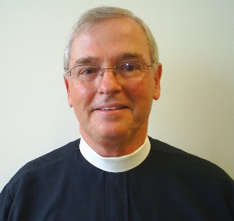

April, 2018
1 | 2 |  | 3 | 4 | 5 | 6 | 7
Easter Sunday |  |  | 10:00-11:30 am  Women’s  Bible Study  6:00 pm Choir | 6:00 pm  Fellowship Supper  Nursery available |  |  | 9:00 to 10:30am  Men’s fellowship & Bible Study
8 | 9 |  | 10 | 11 | 12 | 13 | 14
2nd Sunday of Easter  8:00 am Eucharist  10:00 am Eucharist  11:20 am Coffee  11:30 am Christian Ed  Nursery available | The Annunciation |  | 10:00-11:30 am  Women’s  Bible Study  6:00 pm Choir | 6:00 pm  Fellowship Supper  Nursery available |  |  | 9:00 to 10:30am  Men’s fellowship & Bible Study
15 | 16 |  | 17 | 18 | 19 | 20 | 21
3rd Sunday of Easter  8:00 am Eucharist  10:00 am Eucharist  11:20 am Coffee  11:30 am Christian Ed  Nursery available  Vestry Luncheon |  |  | No  Women’s  Bible Study  6:00 pm Choir | 6:00 pm  Fellowship Supper  Nursery available |  |  | 9:00 to 10:30am  Men’s fellowship & Bible Study
22 | 23 |  | 24 | 25 | 26 | 27 | 28
Family Promise Week  4th Sunday of Easter  8:00 am Eucharist  10:00 am Eucharist  11:20 am Coffee  11:30 am Christian Ed  Nursery available | Family Promise Week |  | Family Promise Week  No  Women’s  Bible Study  6:00 pm Choir | Family  Promise  Week  St. Mark, Evangelist  6:00 pm  Fellowship Supper  Nursery available | Family Promise Week | Family Promise Week | Family Promise Week  9:00 to 10:30am  Men’s fellowship & Bible Study
29 | 30 | Mark Your Calendar!
5th Sunday of Easter  8:00 am Eucharist  10:00 am Eucharist  11:20 am Coffee  11:30 am Christian Ed  Nursery available |  | Sun. May 6 Daughters Gathering
Links to the ways we communicate
Parish Website: http://www.achtna.org
Monthly Newsletters (web + mailed): http://www.achtna.org/newsletters
Sunday Bulletin & Announcement Pg.: http://docs.wixsttic.com/ugd/4a5efa_d2f2833708fd4cb786e26341d2b7e364.pdf
Holy Trinity Mobile App: http://docs.wixstatic.com/ugd/4a5efa_80ea18e8be5a4eb69541c319aa89a00f.pdf
Email Distr. News & messages (If you are not receiving HT emails, please provide your email address to robhartley@comcast.net)
Prayer List (Sun. Bulletin & Web): http://www.achtna.org/parish-prayer-list
Rector’s Blog (North Augusta Anglican): http://holytrinityna.blogspot.com/

Holy Trinity is a congregation of the Anglican Church in North America
Christ-centered, biblically grounded, worshipping in the Anglican Tradition
Sweetwater Center, 160 Merovan Drive, North Augusta, S C 29860
www.achtna.org (803) 341-0075 robhartley@comcast.net Blog: North Augusta Anglican
Bishop: The Rt. Rev. Steve Wood, Rector: The Rev. Rob Hartley
Assisting Clergy: The Rev.’s Dan Brown and Theophilus Iwuji
Vestry: Dianne Havird, Jason Nault, Annabelle Shepherd, Avery Shapiro
Senior Warden: Mike Fekula; Junior Warden: Darren Newman

Holy Trinity is a congregation of the Anglican Church in North America
Christ-centered, biblically grounded, worshipping in the Anglican Tradition
Sweetwater Center, 160 Merovan Drive, North Augusta, S C 29860
www.achtna.org (803) 341-0075 robhartley@comcast.net Blog: North Augusta Anglican
Bishop: The Rt. Rev. Steve Wood Rector: The Rev. Rob Hartley
Assisting Clergy: The Rev.’s Dan Brown and Theophilus Iwuji
Vestry: Annabelle Shepherd, Jason Nault, Dianne Havird, Avery Shapiro Senior Warden: Mike Fekula, Junior Warden: Darren Newman

