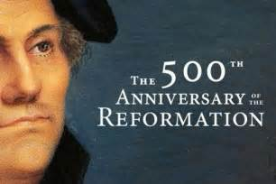
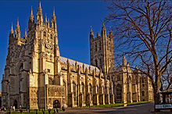
Reformation Celebration
Celebration of the 500th Anniversary
of the Protestant Reformation
Sola Scriptura
(Scripture Alone)

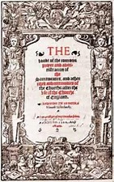
A collect (prayer) crafted by Archbishop Thomas Cranmer
at the beginning of the Protestant Reformation
in the British Isles for
The First Book of Common Prayer (1549)

BLESSED lord, which hast caused all holy Scriptures to bee written for our learnyng; graunte us that we maye in suche wise heare them, read, marke, learne, and inwardly digeste them; that by pacience, and coumfort of thy holy woorde, we may embrace, and ever holde fast the blessed hope of everlasting life, which thou hast geven us in our saviour Jesus Christe.

From “The Book of Homilies” circulated to all English parishes in 1547 onward
An excerpt from Homily #1 titled
“A fruitful exhortation to the reading of holy Scripture.”
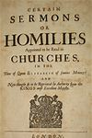
“To a Christian man there can bee nothing either more necessarie or profitable, then the knowledge of holy Scripture, forasmuch as in it is conteyned GODS true word, setting foorth his glory, and also mans duety… Therefore forsaking the corrupt iudgement of fleshly men, which care not but for their carkasse: let vs reuerently heare and read holy Scriptures, which is the foode of the soule (Matthew 4.4). Let vs diligently search for the Well of Life in the bookes of the New and Old Testament, and not runne to the stinking puddles of mens traditions (deuised by mens imagination) for our iustification and saluation.

Articles of Religion,
(first published in 1553)
Article VI
The Sufficiency of Holy Scripture

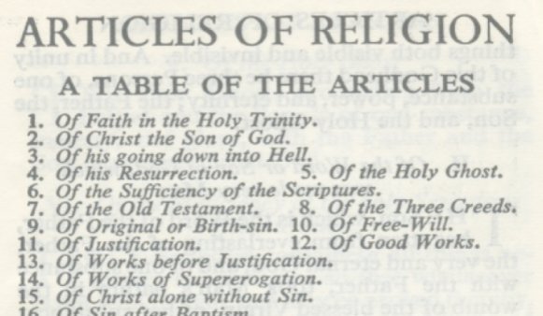

“Holy Scripture containeth all things necessary to salvation: so that whatsoever is not read therein, nor may be proved thereby, is not to be required of any man, that it should be believed as an article of the Faith, or be thought requisite or necessary to salvation.”

