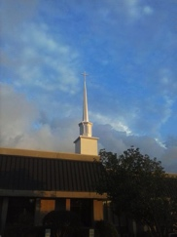
Pentecost- June 2019
Anglican Church of the Holy Trinity
Christ-centered, biblically grounded, worshipping in the Anglican Tradition

Newsletter

Core Values
Present with our Lord and with each other every Lord’s Day.
Committed to growing in our knowledge and love of the Lord.
Serving each other and the world around us in His Name

The Religious and Moral
Foundations of Our Nation
The Rev. Rob Hartley
There is a not-particularly-new movement afoot in this country that strives to define America as a nation in which there is no place for religious ideas or influences in the public square. This has become the new definition of the separation of Church and State. In this movement, religion (particularly Christianity), if it must be exercised at all, is to be a private matter kept out of all public discourse and decision-making. However, my life, and I suspect your life also, is governed by a relationship with God and by the moral and ethical implications that relationship brings. As citizens of this great and democratic nation, it is surely appropriate for us to project our Christian Worldview alongside other worldviews, such as secularism, in influencing the public and political direction of this country.

So, who is making up this new rule that there is no place for Christianity in the public square? The desire and strategy to ban religion from the public discourse is part of a movement called Progressivism. Progressivism is about re-writing, eliminating, or re-shaping issues and institutions judged to be a detriment to its objectives. Among other things, it preaches that religion is a drag on progress, at least progress as the movement defines it. Historical revisionism (revising or reframing history) that is coming out of the Progressive Movement suggests that the first amendment, which calls for the separation of church and state, is about keeping religion out of public discourse. This, however, is
actually not the same thing as the nation’s founding concepts of freedom of religion. Freedom of religion, as envisioned by the Founding Fathers, is simply the need to assure freedom from any state sponsored interference of people worshiping as they desire. Separation of church and state is freedom of religion, not freedom from religion.

The great harm of the Progressive Movement is that of the jettisoning things that have made our country uniquely and highly successful among the nations of the world. Chief among them is the religious, moral, and ethical underpinning of our democracy and economic system. What is in fact happening is that traditional religion is being replaced in the public square with a new religion; it is called Secularism.

The expression of religious convictions was the practice of the vast majority of the founders of this nation. They did not hide their light under a bushel when it came to the influence of God in their lives, or the life of this nation. George Washington said, "The propitious smiles of heaven can never be expected on a nation which disregards the eternal rules of order and right which heaven itself has ordained." And in Washington’s famous farewell address he said, “Of all the habits and dispositions which lead to political prosperity, religion and morality are indispensable supports.”

Christians should strive to assure the ethical character of their leaders as judged from their Christian Worldview. U.S. President and minister of the Gospel, James A. Garfield, stated, "Now, more than ever, the people are responsible for the character of their Congress… If the next centennial [century] does not find us a great nation. . . . it will be because those who represent the enterprise, the culture, and the morality of the nation do not aid in controlling the political forces." George Washington and James Garfield are not isolated examples of the “Faith of Our Fathers.”

Father Rob
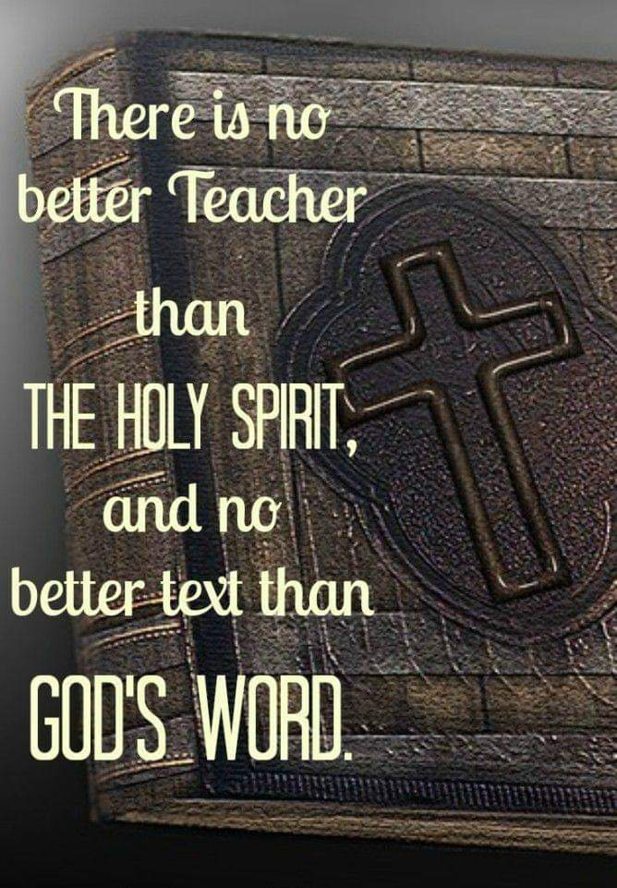

Lighthouse for Life is a non-profit organization seeking to take steps against sex trafficking. It desires to see everyone joined together to put a stop to the trafficking of loved ones around us and to provide grace and restoration to victims being rescued from trafficking.

Lighthouse for Life purposes to teach the people of South Carolina about the realities of the current plague of human trafficking, not just globally or nationally, but right here in our own communities. It strives to EDUCATE and raise awareness about human trafficking and to EMPOWER us to detect the warning signs of potential human trafficking situations in an effort to protect our own communities.
Come to Wednesday night supper-prayer-praise time on June 19
as we host guest speakers from Lighthouse for Life.

Byte from the Bible

I consider that the sufferings of this present time are not worthy to be compared with the glory which shall be revealed in us. Romans 8:18, NKJV

Bad things do happen to those Jesus loves. But remember this spiritual principle: Glory follows suffering, and life follows death. And the lives we live here prior to death are hardly a blink of the eye compared to our glorified time with our Creator. Thanks be to God!

L king to have fun in ministry and service?
Look no farther than the sign-up board to be a part of our
Family Promise hosting during the week of July 7-14.

Homeless families will be living in our church building during that week, and we are privileged to help them move in and out, host, prepare meals, and be sensitive to ways that we may demonstrate the love of Jesus to these folks. The sign-up board will be placed in the fellowship hall during the first week of June.

Progress Report on Calling a New Rector
The Vestry completed its video conferencing interviews of four Rector candidates on May 23. At a subsequent meeting, we identified the top candidates based upon these online interviews and our research of the candidates to date. Vestry members are in the process of checking references for those top candidates. We are also confirming the final Rector Compensation Package and planning to personally visit with the top candidates.

Philippian Study Continues
Our study and discussion of Paul’s letter to the church in Philippi continues on Wednesday nights in June. Did you know that the Philippian congregation was the first Christian church founded on the continent of Europe? And did you know that, while Paul was probably in the worst situation ever (think imprisonment, loneliness, broken health), he wrote this letter of joy and encouragement (think no criticism or indictments). Whether you’ve yet attended these lessons or not, come and grow with us.

~ Yeraldin Will Be Sharing Her Story with Us ~
Sunday, June 16, during Adult Forum
We all have a story to tell when it comes to our journey with the Lord. I have invited Yeraldin Galimi to share hers. Please make special plans to join us in the Adult Forum, Sunday, June 16. Father Rob
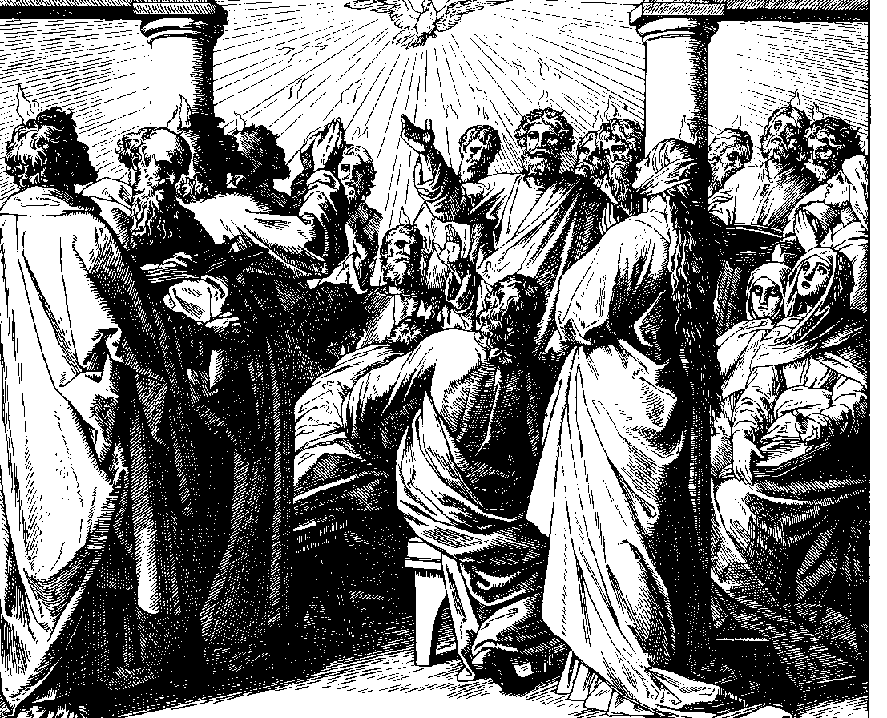
by Julius Schnorr von Carolsfeld
The Chief Ministers of the Church
We Anglicans understand very well who the chief ministers of the Church are, and it is not the clergy. It is, of course, you, the laity. Sometimes we forget this, thinking that is why we keep clergy around. The clergy, of course, do ministry, as well as preach, teach and administer, but chief among the jobs of the clergy is to train and equip the laity to be the real front-line ministers of the church. Clergy are the coaches; you are the players.

Here is an excerpt from the Constitution and Cannons of the Anglican Church in North America (ACNA) concerning the ministers of the church:
Canon 10- Of the Laity- Concerning Ministry: The people of God are the chief agents of the Mission of the Church. The ministry of the laity is to extend the Kingdom of God by so presenting Jesus Christ in the power of the Holy Spirit that people everywhere will come to know Him as Lord and serve Him as King in the fellowship of the Church. The effective ministry of the Church is the responsibility of the laity, no less than it is the responsibility of Bishops and other Clergy. It is incumbent for every lay member of the Church to become an effective minister of the Gospel of Jesus Christ, one who is spiritually qualified, gifted, called, and matured in the faith.

The Feast of Pentecost
Pentecost (Greek: πεντηκοστή), meaning the "the fiftieth day," is one of the seven Principle Feast Days of the Church, ranking alongside Easter and Christmas. It is celebrated on the 7th Sunday after The Day of the Lord’s Resurrection. Counting Easter Sunday itself, that places it 50 days after the Resurrection. The Feast of Pentecost commemorates the descent of the Holy Spirit upon the Apostles and Disciples as described in Acts chapter 2. This year, Pentecost falls on Sunday, June 9. Don’t miss this great celebration.
Source of picture and some text: Wikipedia.
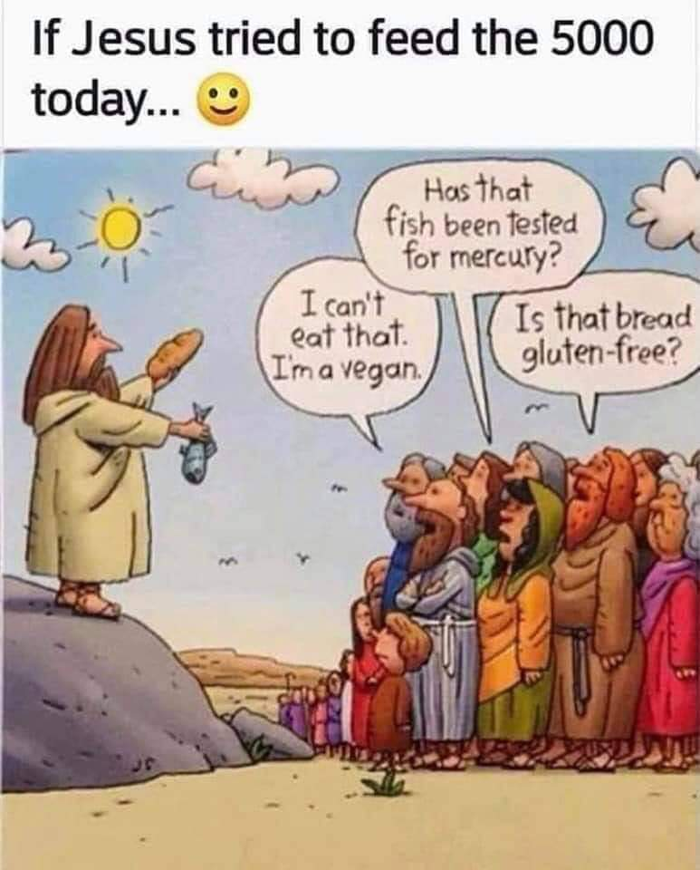

June Lay Ministry Chart
2019 | June 2  7 Easter | June 9  Day of Pentecost | June 16  1 Pentecost | June 23  2 Pentecost | June 30  3 Pentecost | July 7  4 Pentecost
Euch. Min. | Dan W | Bill B | Char’ Rae B | Joe G | Mike H | Paula W
Ushers /  Greeters | Dianne H  Deborah K | Richard M  Jason N  Margaret W | Wayne L  Monte S  Billy H | Char’ Rae B  Dianne H  Deborah K | Wayne L  Richard M  Jason N | Monte S  Margaret W  Billy H
Presenting  Bread/Wine | Susan P  Tracy P | Kevin &  Jami W | Dan &  Leslie W | Margaret W  Bill B | Mike &  Jackie F | Virginia F  Terri F
Prayer Team | Ginger H  Monique T | Nancy H  Wayne L | Rosemarie M  Margaret W | Jackie F  Nancy H | Ginger H  Monique T | Nancy H  Wayne L
Lector-OT | Mike P | Jennifer P | Margaret W | JoEllen B | Brenda B | Tom D
Lector-NT | Richard M | Annette M | Jason N | Mike P | Jennifer P | Margaret W
Altar Guild  [week of] | Virginia F  Marguerite P | Ginger H  Monique T | Annette M  Deborah K | Rosemarie M  JoEllen B | Virginia F  Marguerite P | Ginger H  Monique T
Acolyte Guild | Jada T | Lelan C | Jackie F | Oke I | Andrew H | Isaiah M
If you are unable to fulfil your ministry duties, please find a replacement and let Fr. Rob know.

Holy Trinity
A beacon drawing people to God and into the fellowship of God’s People
Holy Trinity is a congregation of the Anglican Church in North America
Christ-centered, biblically grounded, worshipping in the Anglican Tradition
Sweetwater Center, 160 Merovan Drive, North Augusta, S C 29860
www.achtna.org (803) 341-0075 robhartley@comcast.net Blog: North Augusta Anglican
Bishop: The Rt. Rev. Steve Wood Rector: The Rev. Rob Hartley Assisting Clergy: The Rev.’s Dan Brown and Theophilus Iwuji
Vestry: Mike Fekula (Senior Warden), Bill Bargeloh (Junior Warden), Annabelle Shepherd, Jason Nault, Dianne Havird, Paula Wahl

June, 2019
Upcoming Events  June 1, (1st Sat) Daily Office of Morning Prayer, BCP – 9:00 am  June 4 1st Tuesday Prayer – 10:00 am  June 16 Yeraldin Galimi will be sharing her story with us during Adult Forum  June 19 Guest Speaker from Lighthouse for Life  July 7-14 Family Promise returns to Holy Trinity |  |  |  |  |  | 1
9:00 to 10:20am
Men’s fellowship & Bible Study
2 | 3 | 4 | 5 | 6 | 7 | 8
7th Sun of Easter  8:00 am Eucharist  10:00 am Eucharist  11:20 am Coffee  11:30 am Christian Ed  Nursery available |  | No Women’s  Bible Study  10:00 am  1st Tuesday Prayer  6:00 pm Choir | 6:00 pm  Fellowship Supper  “Owned”  Nursery available |  |  | 9:00 to 10:20am  Men’s fellowship & Bible Study
9 | 10 | 11 | 12 | 13 | 14 | 15
The Day of Pentecost  8:00 am Eucharist  10:00 am Eucharist  11:20 am Coffee  11:30 am Christian Ed  Nursery available |  | St. Barnabas, Apostle  10:00-11:30 am  Women’s  Bible Study  6:00 pm Choir | 6:00 pm  Fellowship Supper  “Never satisfied”  Nursery available |  |  | 9:00 to 10:20am  Men’s fellowship & Bible Study
16 | 17 | 18 | 19 | 20 | 21 | 22
Father’s Day  1st Sun after Pentecost  8:00 am Eucharist  10:00 am Eucharist  11:20 am Coffee  11:30 am Christian Ed  Nursery available |  | 10:00-11:30 am  Women’s  Bible Study  6:00 pm Choir | 6:00 pm  Fellowship Supper  Guest Speaker from Lighthouse for Life  Nursery available |  |  | 9:00 to 10:20am  Men’s fellowship & Bible Study
23 | 24 | 25 | 26 | 27 | 28 | 29
2nd Sun after Pentecost  8:00 am Eucharist  10:00 am Eucharist  11:20 am Coffee  11:30 am Christian Ed  Nursery available | Nativity of  St. John,  the Baptist | 10:00-11:30 am  Women’s  Bible Study  6:00 pm Choir | 6:00 pm  Fellowship Supper  “Waiting”  Nursery available |  |  | St Peter and St Paul, Apostles  9:00 to 10:20am  Men’s fellowship & Bible Study
30 | 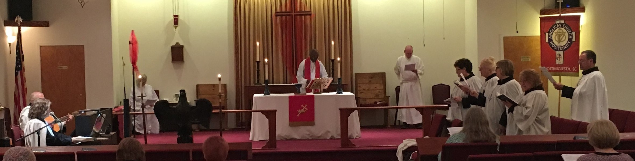
3rd Sun after Pentecost
8:00 am Eucharist
10:00 am Eucharist
11:20 am Coffee
11:30 am Christian Ed
Nursery available
The ways we communicate
Parish website http://www.achtna.org
Monthly newsletters (web + mailed) http://www.achtna.org/newsletters
Sunday bulletin announcement page http://www.achtna.org/events
Access to Holy Trinity Mobile App. http://docs.wixstatic.com/ugd/4a5efa_80ea18e8be5a4eb69541c319aa89a00f.pdf
Email distribution – news & messages To be on the distribution, send email address to robhartley@comcast.net
Prayer List (Sunday bulletin & website) http://www.achtna.org/parish-prayer-list
Rector’s Blog (North Augusta Anglican) http://holytrinityna.blogspot.com/

